Task 10:

Configure base machine as YUM server, so that pc1, pc2, pc3 can download package from pc1

Check whether you can install packages on pc1, pc2, pc3

1. yum server configured for centos (pc1, pc2) and rhel (pc3) in base machine /var/ftp
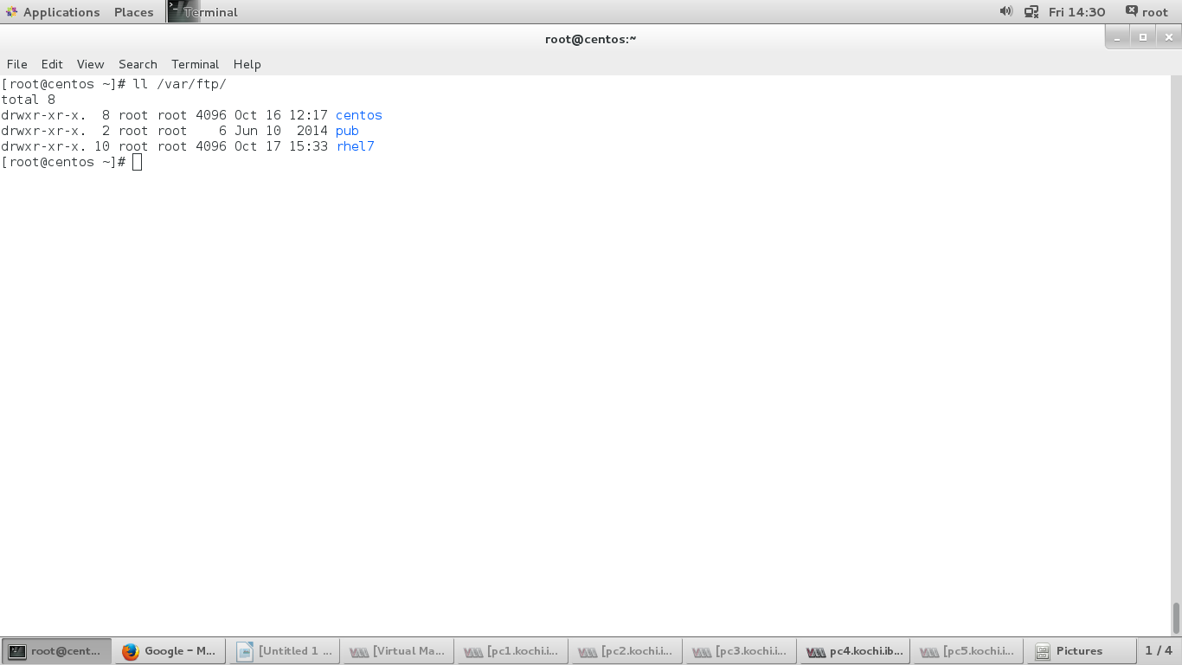
2. yum configured in pc1, pc2, pc3 as below.
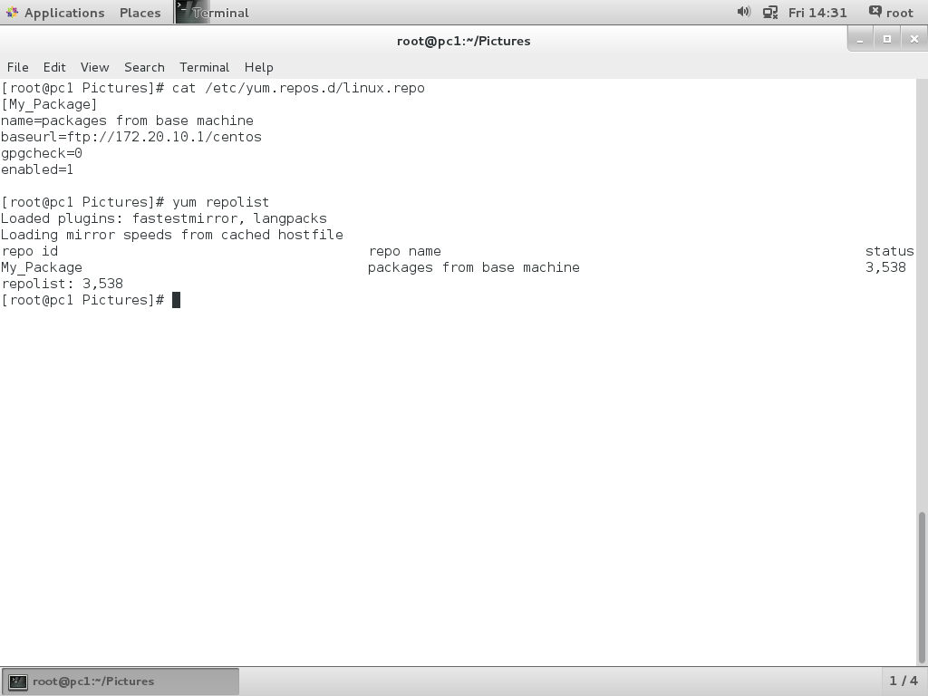

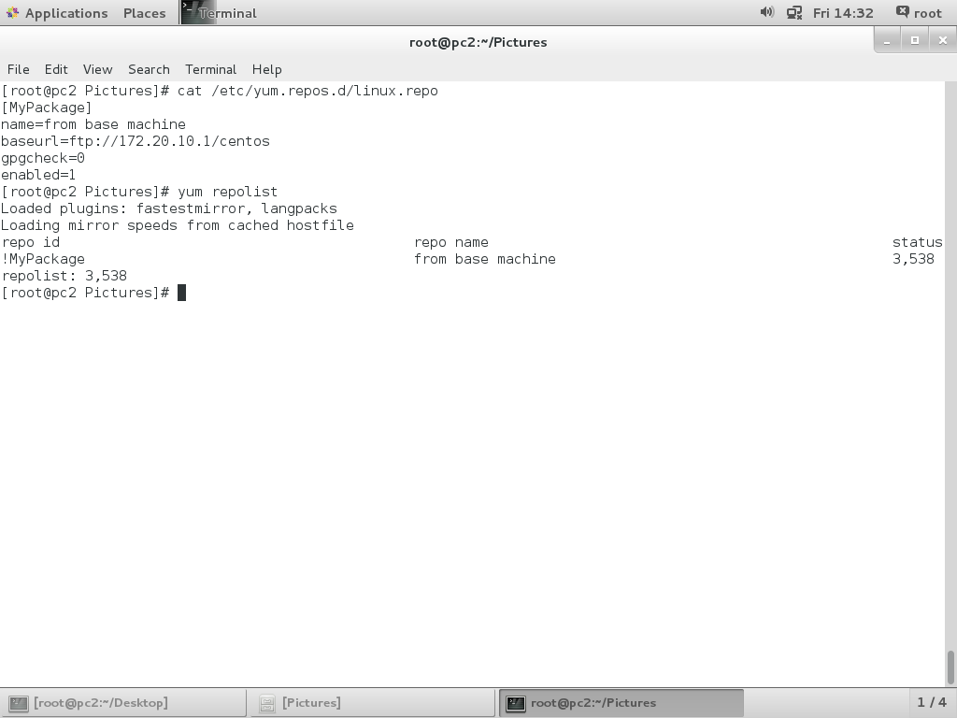
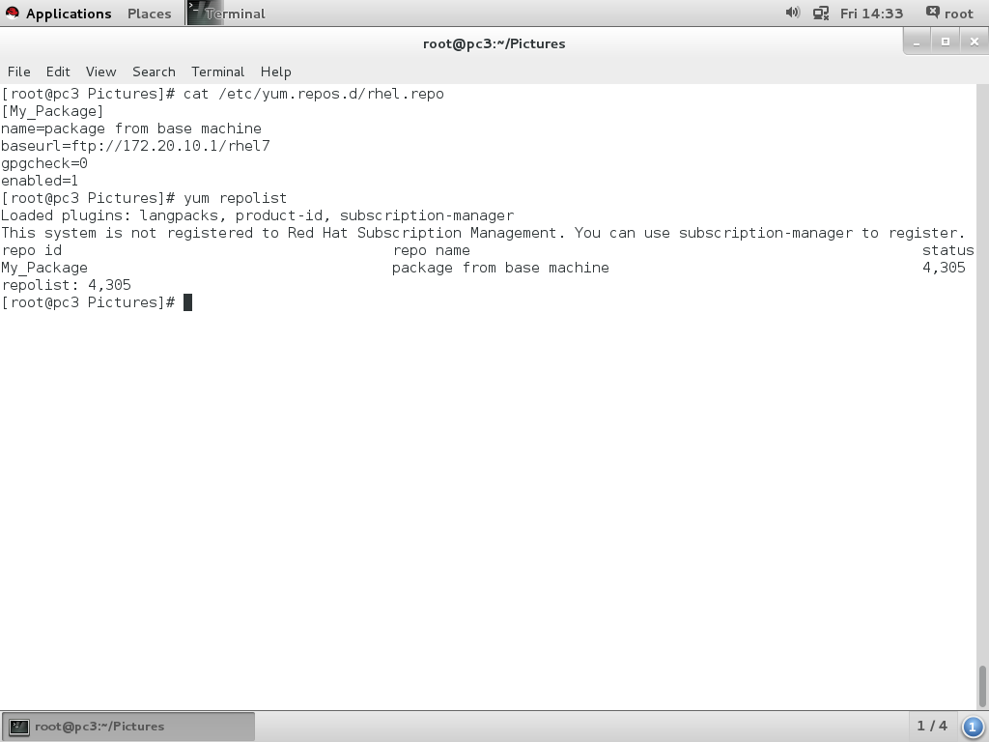
Task 11:
Configure pc2 as DNS Server
- Install using “BIND” package
Optional (Configure a PC2 as Master & PC3 as Slave DNS Server)

1. bin package has been installed in pc2, pc3.
yum install bind bind-utils
2. configuring pc2 as Master DNS.

vim /etc/named.conf

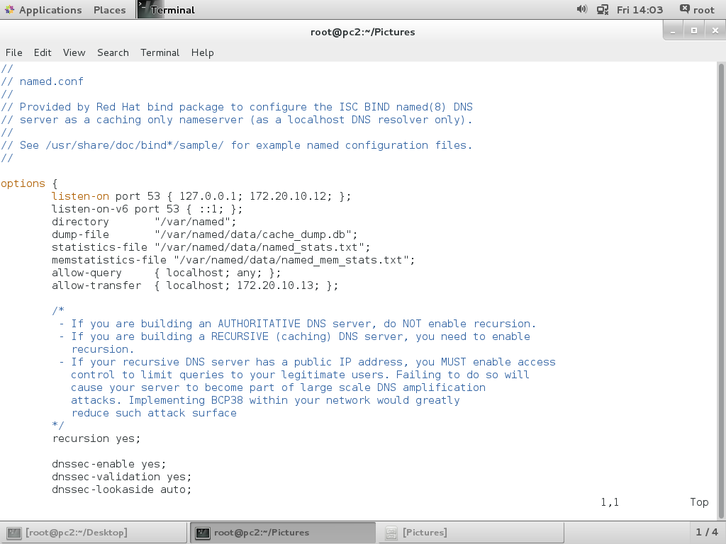

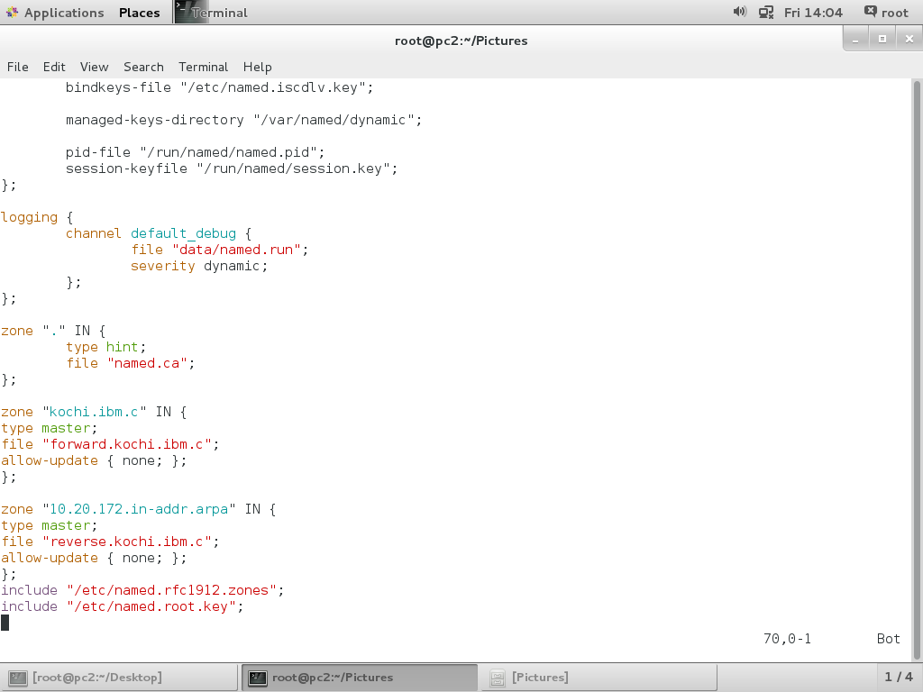
3. vim /var/named/forward.kochi.ibm.c

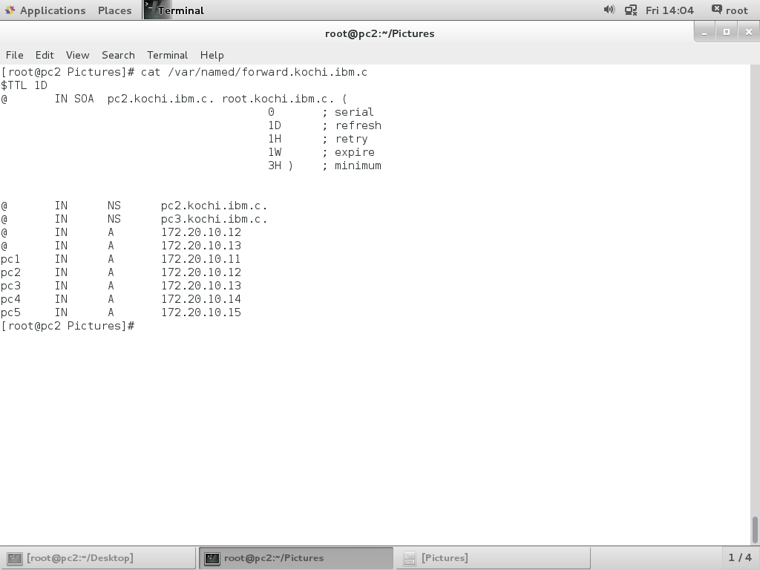

4. vim /var/named/reverse.kochi.ibm.c

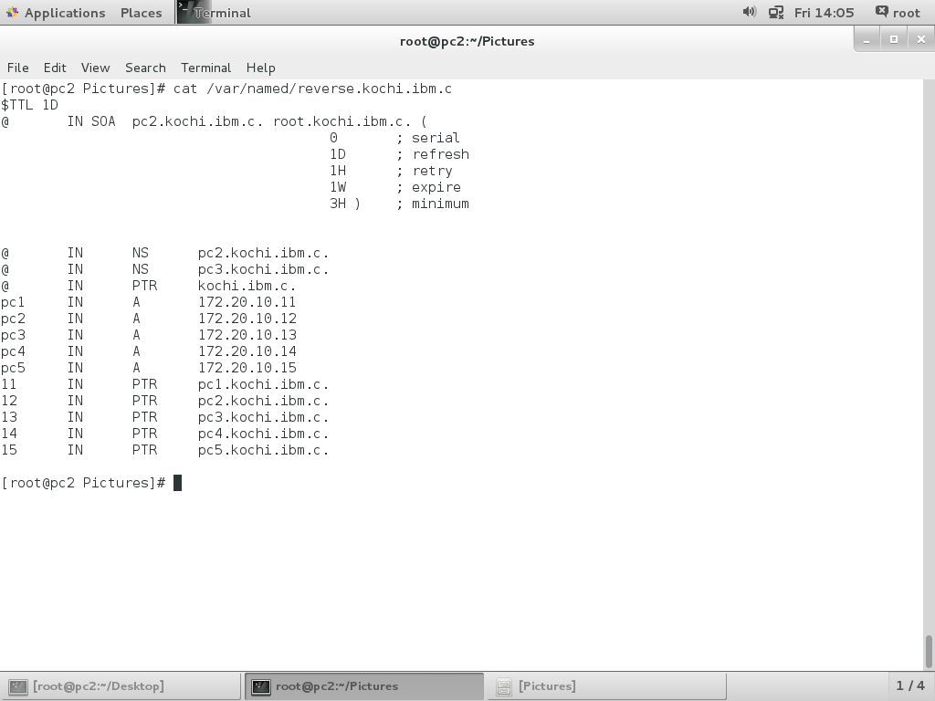
5. chown root:named /var/named/reverse.kochi.ibm.c
chown root:named /var/named/forward.kochi.ibm.c
6. vim /etc/resolv.conf
nameserver 172.20.10.12
search kochi.ibm.c
7. start and enable named service.
8. restart Network Manager service.

9. Configure pc3 as slave DNS server.
10. vim /etc/named.conf
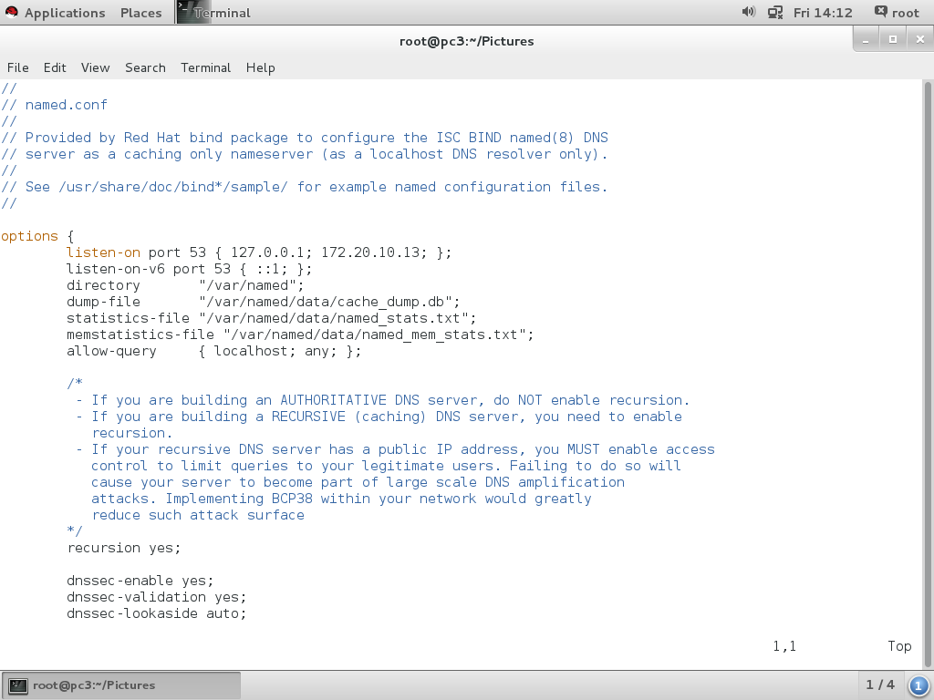
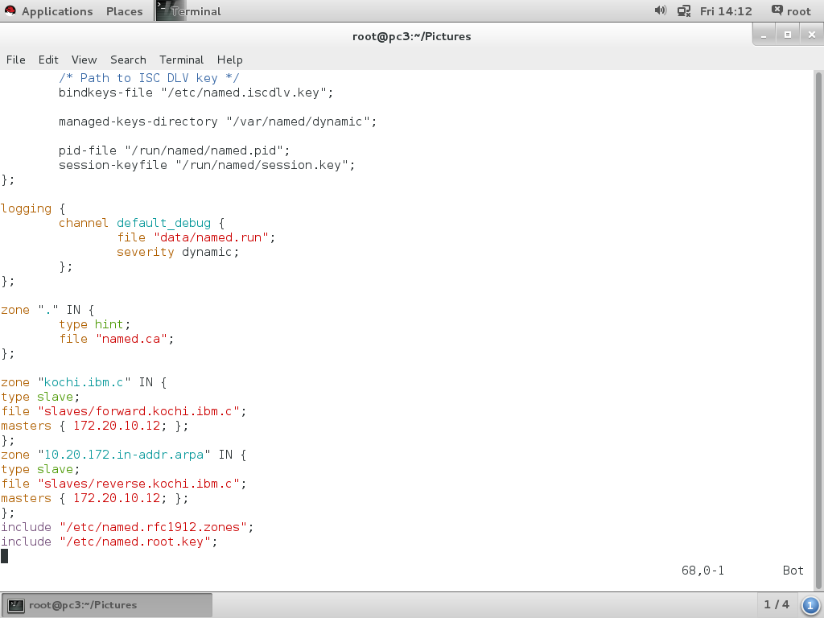
11. vim /etc/resolv.conf
nameserver 172.20.10.12
nameserver 172.20.10.13
search kochi.ibm.c
12. start and enable named service.
13. restart Network Manager service.
14.Test from pc1
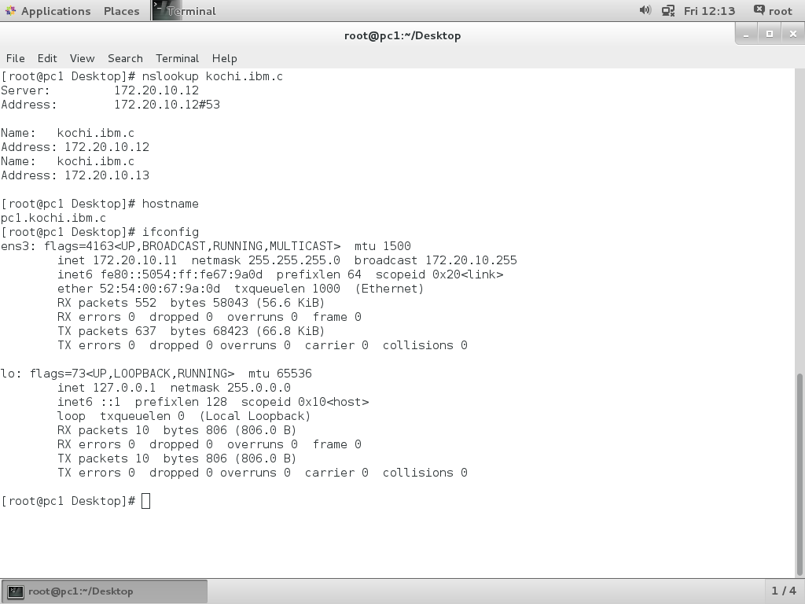
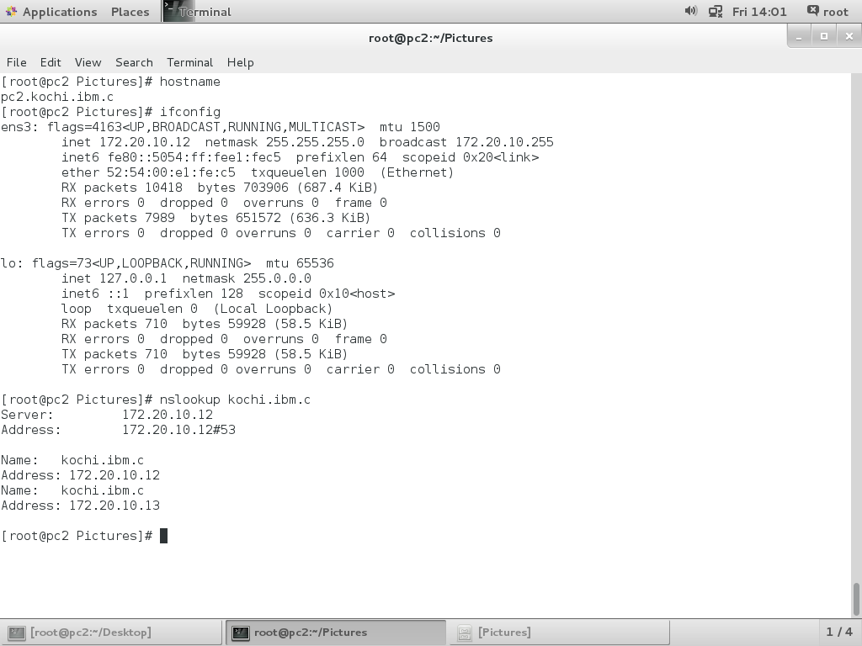
15. Test from pc2
